CAREER OPPORTUNITY DEVELOPMENT, INC.
JANITORIAL MAINTENANCE PROGRAM
HANDBOOK

Table of Contents
CODI Organizational Overview 1
CODI Mission Statement 1
CODI Vision Statement 1
Janitorial Maintenance Program Overview 1
Maintenance Crew Member Staffing and Scheduling 1
Maintenance Procedures 2
Maintenance Supplies 2
Other Contract Specifications 2
Appendix 1: Janitorial Maintenance Crew Procedures and Responsibilities 3
ADDENDUM FOR COVID-19 5
Keeping a Safe Workplace 5
General Hygiene Rules 6
Facemasks 6
Lunch 6
Restrooms 7
Routine environmental cleaning and disinfection procedures 7
Social distancing requirements 7
Hand Sanitizing Stations 8
Entering the Building 8
Transportation 8
How to Wash Cloth Masks 9
GRIEVANCE and APPEAL PROCEDURE 11
GRIEVANCE and APPEAL PROCEDURE Sign-Off 16

Revised--February 2023

CODI Organizational Overview
Career Opportunity Development, Inc. founded in 1970 is a private, not for profit organization that provides comprehensive vocational and residential programming for individuals who are mentally, physically, or economically disadvantaged. CODI provides a holistic program and treatment approach whereby individuals have a right to informed choice and are proactive in program planning.

CODI Mission Statement
CODI is dedicated to motivating, inspiring, and supporting individuals with disabilities and disadvantages to optimize potential and maximize independence.

CODI Vision Statement
Developing opportunities and partnerships for individuals with disabilities by providing diversified, comprehensive, professional, and quality services, which focus on turning disabilities into abilities.

Janitorial Maintenance Program Overview
CODI's janitorial maintenance program delivers comprehensive janitorial services to over 50 publicly owned buildings throughout Atlantic County (See Contracted Sites List). The program is part of CODI's Community Employment Services Division and is overseen by the Vice President of Property Management (VP-PM). Teams of part-time Maintenance Workers (MWs) conduct cleaning activities five days per week, 52 weeks per year under the supervision of Maintenance Supervisors (MSs). MW positions are designed to provide individuals with valuable on-the-job experience, and prepare them for sustainable, permanent jobs in the community.

Maintenance Crew Member Staffing and Scheduling
Job openings for MS or MW positions will be posted by CODI Human Resources internally, and on the CODI website at http://njcodi.org/employment/. Individuals may apply for MW positions through the CODI website. Applicants are interviewed by the VP-PM and the Maintenance Manager (MM). Applicants are processed through standard CODI hiring procedures. Those applicants who are chosen for employment undergo a drug test, criminal background check, and a full-day CODI new hire orientation. At least seventy-five (75) percent of the staff members hired into the janitorial maintenance program must be individuals with disabilities.

The MM and MSs meet once every two weeks to discuss maintenance schedules, and to assign MW work shifts. Each MW is assigned to work no more than 28 hours per week. The VP-PM, MM, and MSs meet once per month to discuss janitorial maintenance routes, MW progress, and any issues related to staffing or the janitorial maintenance program in general.

Individuals may also enter MW positions through CODI's Outsource Center. The Vice President of Operations, Organizational Employment Services (VP-OES) refers interested individuals from the Outsource Center to the VP-PM. These individuals enter the janitorial maintenance program on a trial period to assess whether they are appropriate for part-time employment. During the trial period, individuals continue to be paid through their Outsource Center compensation source (See Outsource Center SOPs). The trial period continues until individuals are deemed ready for part-time employment, or it is decided that they are not appropriate for part-time employment. The MM and MSs will discuss individuals who are in trial periods during the biweekly staffing meetings and assess their readiness for converting from the trial period to part-time employment as an MW.

Individuals who are assessed to be appropriate for part-time MW employment will be directed to follow standard application procedures for the position. The VP-PM will refer individuals who are found not to be appropriate back to the VP-OES. If the MM or MSs decide that any janitorial maintenance personnel are to be terminated, the VP-PM will generate Personnel Action Form (PAF) to initiate termination.

Maintenance Procedures
Following the new hire orientation, MWs are assigned a two-week schedule based on the schedules created by the MM and MSs. MWs meet at the main CODI facility at 8:30 a.m. on their scheduled workdays. Upon arrival, MWs assist their assigned MS with preparing and equipping maintenance vans for the daily janitorial maintenance route. CODI will provide daily lunches for MW and MS staff members. Lunches are obtained by the MS from the CODI kitchen each morning and stored in coolers to be loaded onto maintenance vans along with janitorial equipment.

Individuals who are assigned to work at secure locations (177th Fighter Wing, Atlantic County Courthouse, NJ MVC, State and/or Federal Locations) must undergo the separate security background clearance processes for those locations. Additionally, individuals assigned to secure locations report directly to work at these locations rather than first reporting to the main CODI facility on scheduled workdays.

The MSs provide new MWs on-the-job training at assigned janitorial maintenance facilities. The trainer will conduct a 2-hour janitorial training session once per month at the CODI main facility for any Outsource Center consumers who are interested in joining the janitorial maintenance program on a trial basis. At times MWs will not be directly supervised by MSs during janitorial maintenance shifts. All MWs must submit a signed copy of the Janitorial Maintenance Crew Acknowledgement to the MM prior to performing any janitorial work (See Appendix 1).

All MSs and MWs must adhere to established customer service standards when performing janitorial maintenance duties and must submit a signed copy of the Janitorial Crew Procedures and Responsibilities to the MM prior to performing any janitorial work (See Appendix 2).

All MSs and MWs must adhere to CODI’s Personnel Practices Code and Universal Policies (See Personnel Practices Code and Universal Policies).

Maintenance Supplies
CODI will provide all MSs and MWs with work uniforms upon hiring into the janitorial maintenance program.

Each MS will be responsible for keeping track of janitorial supply levels, and will submit supply requisition forms to the MM at the end of each week. When not in use, janitorial equipment and supplies will be kept in a secured, locked location. Only the VP-PM, the MM, and the MSs will have access to the secured supply location.

All Atlantic County facilities provide paper and plastic bags and soap to the CODI janitorial maintenance crew. The 177th Fighter Wing provides all necessary cleaning products to the CODI janitorial maintenance crew for cleaning the 177th Fighter Wing facilities.

Other Contract Specifications
See individual cleaning contracts for any other specifications regarding maintenance procedures or staffing which may be inconsistent with CODI SOPs. In such cases, contract specifications will supersede CODI SOPs, and janitorial maintenance personnel should abide by contract-specific procedures or directions.

Appendix 1: Janitorial Maintenance Crew Procedures and Responsibilities

Consumers have the privilege to participate in supported employment opportunities in the community. Presently, CODI provides opportunities in food service, janitorial and auto detailing. Below are responsibilities and procedures for consumers that are taken from the Outsource Center to work with Maintenance Crew

Procedures:
- Participants must be properly trained prior to participating in an enclave.
- Consumers are paid hourly wages when participating in enclaves.
- Participants must wear appropriate attire to participate in enclaves. This includes no clothing displaying inappropriate words or images, jeans with holes…wear comfortable shoes, etc.
- Consumers will be supervised by CODI staff when participating, however at times supervisor may be in another area of facility. Consumers must be willing to work hard without constant supervision and direction.
- It is recommended that all participants use CODI bathroom facilities before leaving CODI so as to not have to use customers’ facilities that are being cleaned. There are times when crew will be traveling from one site to another and, when necessary, can stop to use restroom facilities at a public stop. Of course, when absolutely necessary, it is permitted to use customer bathroom, but be sure it is clean before leaving.
- Professional behavior is expected while representing CODI. Respect of coworkers and staff is expected. No foul language is to be used. Friendliness to customers is expected but crew is not permitted to stop working to hold a conversation with a customer.
- Stealing while on an enclave will result in immediate dismissal from the privilege of participating in enclaves.
- Supervisors are expected to be working the entire time with the consumers. Before leaving a work site, supervisors are to inspect work site for completion of tasks and to make sure all supplies are collected for return trip to CODI.
- While on enclaves you are representing CODI. All must realize that their actions could result in the customer being pleased with our services or discontinuing their services.

Sign-off Sheet

I, _________________________________, have read and understand the procedures for participants on enclaves. I understand the attitude, behavior and work that are expected while on enclaves. I understand that I represent CODI and its values while I am in the community.

__________________________________ _________________
Consumer signature Date

___________________________________ ___________________
Guardian signature Date

ADDENDUM FOR COVID-19

The following requirements must be taken to protect self, other consumers, and staff from coronavirus or other infectious diseases. These requirements override any conflicting procedures written above and will be followed until further notice.

- Do not report to work with COVID-19 symptoms including coughing, shortness of breath or difficulty breathing, fever or chills, muscle or body aches, fatigue, vomiting or diarrhea, or new loss of taste or smell and notify a supervisor if illness occurs throughout the day.
- Notify CODI of positive COVID-19 test results for self or anyone residing in the household. Note from doctor or Department of Health confirming recovery, and a negative test for the virus is needed for return.
- If in close contact with someone infected by COVID-19, consumer may not return to program for 14 calendar days after the last contact with infected person provided. Also, consumer must not have any symptoms and must test s negative for the virus. Consumer should not come into physical contact with any other CODI consumer or staff during this time.
- Provide CODI with a copy of all test results.

Keeping a Safe Workplace

The protocol for protecting self and others in the workplace against COVID-19 is outlined by the Center for Disease Control (CDC) guidelines. These are simple everyday practices that can be used both at home and in the workplace to protect against bacteria and viruses and are included in the general hygiene rules below.

General Hygiene Rules

- Practice social distancing.
- Wash hands with warm water and soap for at least 20 seconds after using the restroom, coughing into hand, blowing nose, eating, and throughout the workday.
- Cough/sneeze into elbow. If tissue is used, place tissue in trashcan and wash hands immediately.
- Avoid touching face, nose, mouth, and eyes.
- Avoid handshaking, high fives, and fist bumps.
- Put distance between self and others – preferably 6 feet when available.

Facemasks

- Until wearing facemasks indoors is no longer required by the State of NJ consumers and staff must wear a facemask covering nose and mouth when entering CODI and while in the building.
- Facemask may only be removed when eating lunch.
- Consumers are strongly encouraged to wear a facemask brought from home; however, if mask breaks, becomes soiled, or is forgotten, a mask will be provided by CODI.

Lunch

- Consumers must remain on-site for lunch.
- Lunch must be provided from home or purchased from CODI’s kitchen.
- Food take out/deliveries are not permitted.
- Consumers are not permitted to share lunches, snacks, or beverages with others.
- Microwaves, refrigerators, and water fountains are not available to reduce frequently touched items.
- Lunch will be eaten at workstations.

Restrooms
- Only one person at a time is permitted in the restroom.
- Touch-sensitive lights by restrooms must be used, which indicate when restroom is in use. Turn light on and off with elbow, instead of hand.
- Restrooms must stay clean. Dispose of paper products properly and completely flush toilets.
- Consumers must wash hands for 20 seconds using soap and water after using restroom. As a reminder, signs are posted in restrooms with CDC instructions for proper hand washing.

Routine environmental cleaning and disinfection procedures

- All high touch areas will be sanitized four times daily.
- Consumers are required to disinfect work area before work begins, before and after lunch, and end of shift.

Social distancing requirements

- Until social distancing is no longer required by the State of NJ everyone at CODI must practice social distancing.
- Chairs and tables are spaced to follow social distancing guidelines. Consumers may not move chairs to sit closer to other consumers or for any other reason. Chairs are to stay at opposite ends of each table.
- Seats are assigned, and consumers will return to assigned seats daily to minimize contact with other consumers.
- Consumers must follow one-way walking paths in Outsource Center.
- Lockers are off-limits until social distancing measures are loosened. Personal belongings can be stored under workstations. CODI will provide storage containers at consumer's request.
- Consumers are not permitted to assist staff or customers with deliveries or drop-offs.

Hand Sanitizing Stations

Hand sanitizer dispensers are placed throughout the building in workstations, common areas, offices, and meeting rooms. Consumers are encouraged to use hand sanitizer throughout the day as needed.

Entering the Building

Consumers must adhere to the following guidelines when entering the building:

- Consumers and staff are required to complete a temperature check using the non-contact body temperature scanner upon entering the facility.
- Consumers or staff appearing to have acute respiratory illness symptoms (i.e., cough, shortness of breath) or exhibit a fever upon entrance will immediately exit the building and return home. If this is not possible, consumer will be required to remain in the isolation room until arrangements to return home are completed.
- At the end of each day, consumers must remain at assigned table until transportation arrives to avoid overcrowding exit.

Transportation

CODI will not be providing transportation services upon reopening.

How to Wash Cloth Masks
Masks are an additional step to help slow the spread of COVID-19 when combined with every day preventive actions and social distancing in public settings.
Masks should be washed after each use. It is important to always remove masks correctly and wash your hands after handling or touching a used mask.
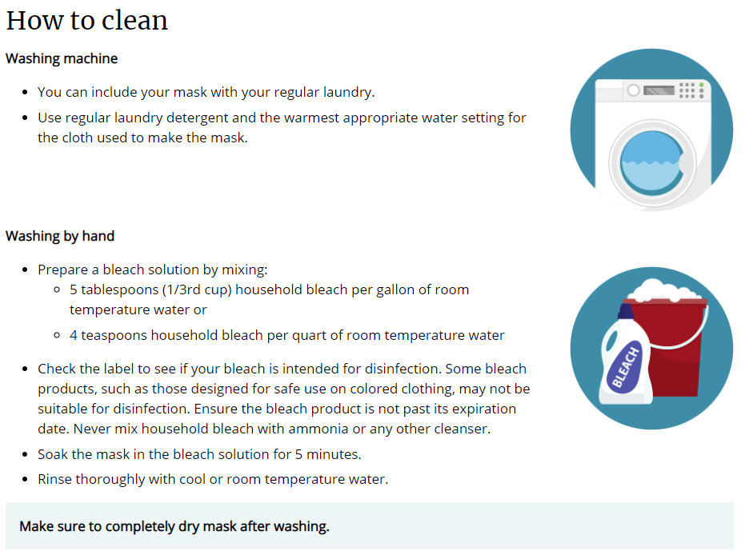
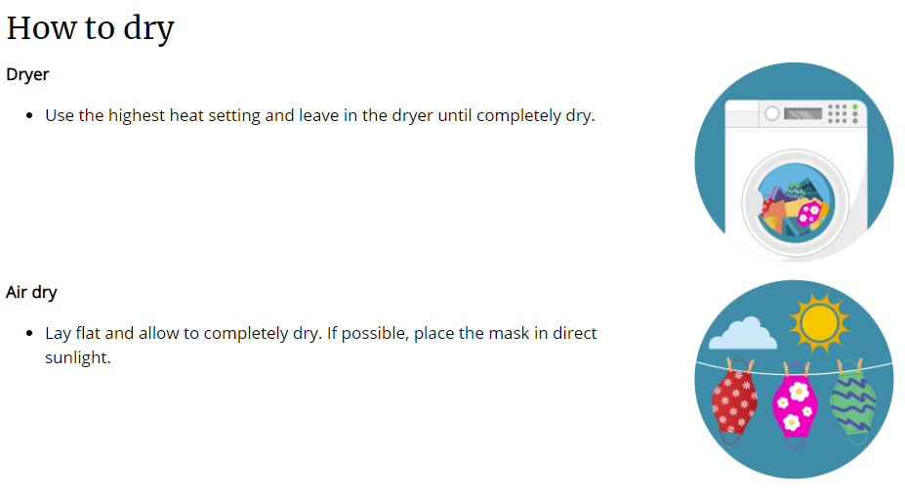

GRIEVANCE and APPEAL PROCEDURE

A grievance is an official statement of complaint over something believed to be wrong or unfair. Consumers have 30 calendar days after an incident to file a grievance. Consumers may file a grievance if they believe they witnessed or experienced CODI staff:
- Disregarding consumer rights
- Treating consumer unfairly
- Not providing services offered by the program
- Intimidating or bullying consumer
- Treating consumer inhumanely or without dignity
- Allowing consumer to be put at risk by another consumer
Grievances do not include consumer to consumer complaints. No one will be punished for filing a grievance. CODI will continue to provide services while trying to resolve the grievance.

CODI encourages consumers to talk to staff about their concerns before filing a grievance. If the grievance is not resolved, CODI encourages consumers to talk with a supervisor where they work, live, or receive services.

If the concern is not resolved, please obtain a grievance form online at www.njcodi.org or request a grievance form from any CODI staff member. Forward completed grievance form electronically to TWinchester@njcodi.org or mail completed form to:

CODI
Attention: Taran Winchester (Director of Quality Improvement)
901 Atlantic Avenue
Egg Harbor City, NJ 08215

Taran Winchester, the Director of Quality Improvement will:
- Confirm grievance was received.
- Begin investigation of grievance within three days of receipt.
- Complete an investigation within ten days of receipt.
- Notify all parties of the outcome within five days of completing the investigation.
If not satisfied with the decision, the consumer may appeal the decision to the President/CEO. The appeal must be in writing and received by President/CEO within five business days of receipt of grievance outcome report. President/CEO will respond within five business days.
Grievance Form

Name(s) of individual(s) submitting grievance: ____________________________
____________________________________________________________________________________________________________________________________
Summary of grievance: ______________________________________________
______________________________________________________________________________________________________________________________________________________________________________________________________
Requested actions to resolve grievance: __________________________________
______________________________________________________________________________________________________________________________________________________________________________________________________
Signature of Program Participant or staff submitting grievance on behalf of a consumer:
______________________________________ Date: _____________________
Please email this form to twinchester@njcodi.org or have staff scan for you,
or mail completed form to:
Career Opportunity Development, Inc.
Attention: Taran Winchester (DQI)
901 Atlantic Avenue
Egg Harbor City, NJ 08215

□ To Quality Improvement Date: ___________________
□ To Human Resources Date: ___________________
□ To Risk Management Committee Date: ___________________
CIR □ Yes □ No ; If Yes, #___________ DAF □ Yes □ No
□ Other: _________________________________________________________________

CODI encourages consumers to use our grievance procedure. If you are not satisfied you
may contact the external resources listed below:

In New Jersey, Call 2-1-1 for Help and Hot Lines http://www.nj211.org/
Community Health Law Project (856) 858-9500
4 East Jimmie Leeds Road, Suite 8, Galloway, NJ 08205 http://www.chlp.org/

Adult Protective Services (609) 645-5965 or (888) 426-9243
101 Shore Rd, Room 210, Northfield, NJ 08225
http://www.atlantic-county.org/intergenerational-services/adult-protective-services.asp

Disability Rights NJ (609) 292-9742 or (800) 922-7233
210 S Broad St, 3rd Floor, Trenton, NJ 08608 http://www.drnj.org/

Atlantic County Mental Health Administrator (609) 645-7700 ext. 4519
Attn: Kathy Quish email: Quish_Kathleen@aclink.org
101 S Shore Rd, Northfield, NJ 08225

NJ Division of Mental Health & Addiction Services (877)285-2844
Mental Health Advocacy, Hughes Justice Complex
25 Market St, Trenton, NJ 08625
http://www.nj.gov/defender/structure/mha/ email: njmentalhealthcares@mhanj.org

NJ Division of Mental Health & Addiction Services (DMHAS)
Recovery Advocate (609) 438-4351
Ombudsperson/Susanne Mills (609) 438-4321
5 Commerce Way, Suite 100, P.O. Box 362, Hamilton, NJ 08625
http://www.state.nj.us/humanservices/dmhas/resources/services/recovery/advocate.html

NJ Division of Youth and Family Services (DYFS) 877-NJ-ABUSE (877) 652-2873
Child Protection Services DYFS Action Line (800) 331-3937
http://www.state.nj.us/nj/community/family/

NJ Division of Developmental Disabilities (DDD) (609) 476-5200
5218 Atlantic Ave, Suite 205
Mays Landing, NJ 08330 http://www.state.nj.us/humanservices/ddd/home/

NJ Division of Vocational Rehabilitation (609) 813-3993 or (609) 292-5987
2 S. Main St, 1st Floor, Suite 2, Pleasantville, NJ 08232
or, PO Box 398, Trenton, NJ 08625 http://www.state.nj.us/humanservices/cbvi/services/vocation/

Atlantic County Government/Fran Kuhn (609) 485-0153 ext 4809
2 S. Main St, Pleasantville, NJ 08232

GRIEVANCE and APPEAL PROCEDURE Sign-Off

On ___________________________ Career Opportunity Development, Inc., Grievance
Date

and Appeal Procedure was reviewed with _____________________________________.
Consumer

I have received a copy of Career Opportunity Development, Inc. (CODI’s) Grievance and Appeal Procedure.

_____________________________ ____________________
Consumer Signature Date

______________________________ ____________________
Guardian Signature-if applicable Date

If guardian is not present at the time of review, an original signed acknowledgment will be forwarded to them within five (5) days for signature. A copy of signed acknowledgment with the date of when acknowledgment was sent to guardian will be maintained in consumer’s file until original is signed by guardian and returned.

On _________________________, I _______________________________
Date Staff/Supervisor

forwarded this acknowledgment to _________________________________
Name of Guardian
for their signature.

