VOCATIONAL CONSUMER HANDBOOK

CAREER OPPORTUNITY DEVELOPMENT, INC.
(CODI)
901 ATLANTIC AVENUE
EGG HARBOR, NEW JERSEY 08215
(609) 965-6871

Revised: April 21, 2023
TABLE OF CONTENTS
Welcome 1
Mission Statement 1
Vision Statement 1
Attendance 1
Daily Schedule 2
Pay Information 2
Holidays 3
Vacation/Sick Pay 3
Weather Closing 4
Input From Individuals Served 4
Outsource Center Rules & Procedures 4
Dress Code 6
Smoke- Free Workplace 6
Employment Opportunities 6
Employment Procedures 7
Emergency Procedures 8
Emergency Contact and Information 9
Suicide Risk 9
Re-Entry 9
Access to Consumer File 10
Consumer Rights 10
Grievance Procedure for Consumers 12
Harassment 15
Abuse 16
Disciplinary Procedure 16
Stephen Komninos’ Law 17
Notice of Privacy Practices 18
ADDENDUM FOR COVID-19 23
Vocational Consumer Handbook Review Sheet 30

Welcome

Welcome to CODI. While providing a broad range of services, CODI partners with consumers to increase job-related and independent living skills. This handbook explains CODI programs, services, policies, and procedures.

CODI strives to assist consumers with:

- Reaching their highest work capacity
- Maximizing earning ability
- Completing all stages of production work

Mission Statement

“CODI is committed to enriching personal, social, and economic independence of individuals with disabilities and disadvantages through employment and housing.”

Vision Statement
“People of diverse backgrounds and experiences working together to foster inclusive communities where individuals, regardless of disabilities and disadvantages, work or volunteer, live in a safe - comfortable home, recognize their value and worth, and feel empowered to make a positive impact.”

Attendance

Consumers are expected to arrive on time and follow an agreed-upon work schedule. Consumers must call CODI (609) 965-6871 if they are absent or late. Outside appointments such as doctor’s visits should be scheduled after work hours when possible.

Consumers absent for sickness for three or more days must get a doctor’s note. Doctor’s notes are to be given to counselor upon return to work.

Individuals absent for three weeks or more without notice must notify counselor when they are ready to return to work.

Daily Schedule

8:30 – 9:00 a.m. | Clock in at CODI
9:00 – 11:45 a.m. | Work or training activities
11:45 a.m. – 12:15 p.m. | Lunch
12:15 – 2:30 p.m. | Work or training activities
2:30 p.m. | Clock out and leave CODI

Consumers with community time may sign-out and leave the building during lunch. Consumers must return on time and sign-in after lunch.

Consumers leaving CODI using NJ Access Link or Atlantic County transportation leave when their ride arrives.

Pay Information

Consumers receive pay for Outsource Center work. Consumers receive their paychecks bi-weekly on Friday.

Net paychecks reflect:
- Piece rate (number of pieces finished) or
- Hourly rate, and
- Payroll taxes when required

CODI complies with Department of Labor pay rates. Consumers with questions about their paycheck should speak with their supervisor.

Holidays

Consumers receive pay for the following holidays:

- New Year’s Day
- Dr. Martin Luther King Day
- President’s Day
- Memorial Day
- Independence Day
- Labor Day
- Veteran’s Day
- Thanksgiving Day
- Winter Break

Holiday pay is based on production rate.

Vacation/Sick Pay

Consumers who have been at CODI for one year or more receive:
- Five paid vacation days
- Five paid sick days

Pay for vacation days and sick days is based on production rate.

Weather Closing

To find out if CODI is closed due to bad weather, please call 609-965-6871. Closings will be announced at the end of the recorded message.

Input From Individuals Served

CODI’s staff and board of directors are committed to providing quality services. We base our programs on the needs and desires of the consumers served.

Consumers can place a suggestion in the box located in the back of the Outsource Center daily.

Consumers have an opportunity during an advocacy meeting held daily after their lunch break. They can make suggestions, express concerns and ask questions regarding the program and facility. This information is gathered to improve service provided. Consumer input is also obtained through annual satisfaction surveys.

Information and recommendations gathered through suggestion box submissions, consumer advocacy meetings, and satisfaction surveys are reviewed by the President/CEO, Leadership, and CODI’s Board of Directors. Consumer input is the basis for purchases, changes in policy or procedure, programs, and events.

Outsource Center Rules & Procedures

Attend CODI regularly. Consumers are required to attend program three to five days each week.
The exception is if documentation is provided proving they attend another day program three days each week.

- Be at workstation, ready to work at 9:00 a.m.
- Report an expected absence to OES Manager.
- Report housing changes to OES Manager.
- Return from breaks on time.
- If consumer leaves CODI for lunch:
  - Sign out when leaving.
  - Sign in when returning.
- Immediately report all injuries to a supervisor.
- Participate and complete assigned tasks.
- Keep work area neat, with no food or drinks while working.
- Leave large sums of money at home.
- CODI is not responsible for electronics and games that consumers bring to work.
- Recharge cell phones at home.
- Turn off cell phones during working hours.
Also, the following actions are not allowed:
- Borrowing or lending money
- Stealing
- Leaving assigned work area without permission
- Hugging or kissing other consumers or staff
- Yelling, sitting on the tables, or using abusive talk
- Entering the shipping area without permission
- Operating any machinery without permission
- Bringing knives or other weapons to CODI
Failing to follow these rules may result in disciplinary action.

Dress Code

Consumers must follow CODI’s dress code. Examples of appropriate clothing:

- Plain T-shirts
- Pants or jeans
- Mid-thigh or longer shorts
- Mid-thigh or longer skirts
- Boots
- Sneakers
- Low-heeled, closed-toe shoes

Consumers may not carry purses, backpacks, or other bags around the Outsource Center. Consumers must store purses, backpacks, and bags under their seats or in a locker.

Smoke- Free Workplace

CODI’s smoking rules:

- No smoking (including vaping) inside any CODI building
- Smoking is permitted outside only in marked Smoking Area.
- Smoking is permitted only at lunchtime and after work hours.

Employment Opportunities

Counselors work with EE consumers to shift into hybrid, supported, or competitive employment.

CODI staff may recommend an individual for employment based on:

- Production speed and quality
- Workplace behavior
- Attendance
CODI’s hybrid program allows consumers to have a job in the community one or more days or nights a week and attend CODI’s Outsource Center on days off.

Consumers may transition into supported employment and not attend the Outsource Center on days off.

Consumers expressing an interest in competitive employment must notify the OES Manager.

OES Manager and employment specialist will evaluate consumer’s skills. Employment specialist or OES Manager will notify consumer of the decision.

Employment Procedures
- Training is received before going to the work site.
- Vocational training may be unpaid.
- Consumers receive hourly wages.
- Professional behavior is expected.
- Bad language is not permitted.
- Respect customers and co-workers.
- Stealing is not permitted.

Emergency Procedures

CODI holds emergency drills monthly to prepare consumers and staff for emergencies.

Consumers are responsible for knowing the location of emergency exits and evacuation procedures.

When the fire alarm sounds, or the flashing red light comes on:
- Stay calm.
- Walk quickly to the nearest exit.
- Leave the building.
- Stay with work section.
- Go to the closest group if not with work section and notify supervisor.
Please notify supervisor or nearest staff member of a personal emergency, sickness, or injury. If medical attention is needed, CODI staff may:
- Treat the injury with basic first aid.
- Call 911.
- After medical evaluation, EMTs may provide transportation to the hospital.
- If this happens, consumer medical information will be provided to the EMTs and the hospital.

If consumer needs medical attention, the counselor will notify parents, guardian, and case manager.

Emergency Contact and Information

Emergency and medical information are updated annually. Please notify counselor or program manager when any information changes.

Suicide Risk

CODI safeguards the lives of consumers. VP of OES talks with a consumer who may want to harm themselves.

If it is determined that a consumer is in immediate danger, 911 will be called. Individuals who do not go to the hospital may be advised to seek licensed counseling. A staff member shall notify the individual’s guardian, case manager, or emergency contact of the suicide risk.

Returning to CODI after hospitalization or counseling requires written clearance from hospital, doctor, or licensed counselor.

Re-Entry

Consumers who leave CODI’s Outsource Center due to the following may call CODI and return to work within one year:
- Interruption
- Employment
- Relocation
- Transfer to another agency
- Medical leave
- Personal choice

Access to Consumer File

All information in consumer files is confidential. Consumers choosing to look at their file shall complete the following:

- Obtain Request for File Information form from the OES Manager.
- Complete form and if consumer is own guardian, sign the form.
- If consumer has a guardian, guardian must sign the form and give permission for consumer review.
- Return form to the OES Manager.

OES Manager will answer the request within ten working days.

Consumers may only view information written by CODI staff.

Consumer Rights

All individuals receiving services from CODI have rights. CODI’s staff, the board of directors, or volunteers must not violate a consumer’s rights.

It is the duty of the staff, the board of directors, and volunteers to make sure that every individual:

- Gets their services without unfair treatment, bullying, or teasing because of:
- race or skin color
- religion or religious practices
- male/female status or because they don’t look or dress like a typical male/female
- pregnancy
- actual or felt sexual preference
- who their parents and grandparents are
- their age
- what part of the world they are from or look like they are from
- whether they are single, married, or divorced
- whether they have a domestic partner or civil union status
- whether or not they were in the military
- their political beliefs
- unusual or unexpected passed down traits
- a mental or physical disability which includes alcoholism, obesity, HIV/AIDS, and substance abuse
- whether they may or may not be in treatment or recovery from substance use
- Get their services free from favoritism, embarrassment, and neglect.
- Are protected from being mistreated over or about money.
- Are treated professionally.
- Get their services honestly, decently, and fairly.
- Are treated respectfully, with courtesy, and with dignity.
- Are free to express their opinions and feelings without revenge.
- Are free from being punished physically.
- Are free from being forced to work.
- Get medical and other care in a place where they are not confined, restrained, and kept alone.
- Are not assumed to be unable to do the work or speak for themselves.
- Ask for and get simple changes so they can practice their religion.
- Choose not to have any religious practices.
- Have access to proper emergency medical care.
- Actively share in putting together their service plan.
- Have the right to see and look over their health and personal information.
- Have the right to ask for their health and personal information to be changed if it is wrong.
- Have the right to send in a grievance and get an answer without revenge.
- Be given a copy of the Grievance Procedure.
- Have contact with someone who can explain things in their language.
- Have health and personal information kept private.
If consumer feels any of these rights have been violated, contact: Community Health Law Project, (856) 858 – 9500.

Grievance Procedure for Consumers

A grievance is an official statement of complaint about something believed to be wrong or unfair. Consumers receive a copy of this procedure on admission. Consumers have 30 calendar days after an incident to file a complaint. Individuals may file a claim if they believe they saw or experienced CODI staff:
- Disregarding consumer rights.
- Treating consumer unfairly.
- Not providing services offered by the program.
- Intimidating or bullying consumer.
- Treating consumer inhumanely or without dignity.
- Allowing consumer to be put at risk by another consumer.

Grievances do not include consumer-to-consumer complaints. No one will be punished for filing a grievance. CODI will continue to provide services while trying to resolve the grievance.

A staff member can provide a consumer with a grievance form to complete. Assistance will be provided upon request.

CODI encourages consumers to talk to staff about their concerns before filing a grievance. If concern is not resolved, please obtain a grievance form online at www.njcodi.org or request a grievance form from any CODI staff member.

Forward completed grievance form electronically to TWinchester@njcodi.org or mail completed form to:
CODI
Attention: Taran Winchester (Director of Quality Improvement)
901 Atlantic Avenue
Egg Harbor City, NJ 08215

Taran Winchester, the Director of Quality Improvement (DQI) will:
- Confirm grievance was received.
- Begin investigation of grievance within three days of receipt.
- Complete an investigation within ten days of receipt.
- Notify all parties of the outcome within five days of completing the investigation.
If not satisfied with the decision, the consumer may appeal the decision to the President/CEO. The appeal must be in writing and received by President/CEO within five business days of receipt of grievance outcome report. President/CEO will respond within five business days.

CODI encourages consumers to use our grievance procedure. If you are not satisfied, you may contact:

In New Jersey, Call 2-1-1 for Help and Hot Lines http://www.nj211.org/

Community Health Law Project (856) 858-9500
160 South Pitney Road, Galloway, NJ 08205 http://www.chlp.org/

Adult Protective Services (609) 645-5965 or (888) 426-9243
101 S. Shore Rd, Shoreview Building, Northfield, NJ 08225
http://www.atlantic-county.org/intergenerational-services/adult-protective-services.asp

Disability Rights NJ (609) 292-9742 or (800) 922-7233
210 S Broad St, 3rd Floor, Trenton, NJ 08608 http://www.drnj.org/

Atlantic County Mental Health Administrator (609) 645-7700 ext. 4519
Attn: Kathy Quish email: Quish_Kathleen@aclink.org
101 S Shore Rd, Northfield, NJ 08225

NJ Division of Mental Health & Addiction Services (877)285-2844
Mental Health Advocacy, Hughes Justice Complex
25 Market St, Trenton, NJ 08625
http://www.nj.gov/defender/structure/mha/ email: njmentalhealthcares@mhanj.org

NJ Division of Mental Health & Addiction Services (DMHAS)
Consumer and Recovery Advocate (609) 438-4321
DMHAS Ombudsman email: dmhas.ombudsman@dhs.nj.gov
http://www.state.nj.us/humanservices/dmhas/resources/services/recovery/advocate.html

NJ Division of Child Protection and Permanency 877-NJ-ABUSE (877) 652-2873
Child Protection Services Action Line (800) 331-3937
http://www.state.nj.us/nj/community/family/

NJ Division of Developmental Disabilities (DDD) (609) 476-5200
5218 Atlantic Ave, Suite 205
Mays Landing, NJ 08330
http://www.state.nj.us/humanservices/ddd/home/

Ombudsman for Individuals with Intellectual or Developmental Disabilities and Their Families (609) 984-7764
Department of the Treasury, PO Box 205, Trenton, NJ 08625
https://www.nj.gov/treasury/assets/contact/ombudsman/contact-ombudsman.shtml

New Jersey Council on Developmental Disabilities (609) 292-3745 or (800) 792-8858
Mary Roebling Building, 20 West State St, 6th Floor, Trenton, NJ 08608
or, PO Box 700, Trenton, NJ 08625-0700
email: njcdd@njcdd.org

NJ Division of Vocational Rehabilitation (609) 813-3993 or (609) 292-5987
2 S. Main St, 1st Floor, Suite 2, Pleasantville, NJ 08232
or, PO Box 398, Trenton, NJ 08625
http://www.state.nj.us/humanservices/cbvi/services/vocation/

Atlantic County Government/Fran Kuhn (609) 485-0153 ext. 4809
2 S. Main St, Pleasantville, NJ 08232

Harassment

Harassment is unwelcome or hostile conduct and speech. CODI does not tolerate harassment, and it is against the law. Examples of undesirable or hostile behavior are:
- Offensive jokes
- Comments that put-down another person
- Teasing
- Bullying
- Making another person afraid
- Using foul language
- Continually asking for money, food, or cigarettes

If consumer feels harassed:
- Tell the person to stop right away.
- Report the behavior to supervisor or counselor.

If consumer cannot talk to their supervisor or counselor, tell the VP of OES.

CODI disciplines consumers and staff members who harass people. Staff members may face termination. Consumers may have an interruption of services.

Abuse

CODI protects the well-being of all consumers. Consumers and staff members are not allowed to cause harm to anyone. Consumers must tell a supervisor they are hurt or feel threatened, even if it seems harmless.

If consumer cannot tell a supervisor, they should tell the counselor or VP of OES.

CODI disciplines people who harm others:
- Staff members may be terminated.
- Consumers may have an interruption of services.

Disciplinary Procedure

When discipline or correction of behavior is required, CODI follows a disciplinary procedure. The procedure is as follows:

- Verbal warning
- Written warning
- 1-day interruption
- 3-day interruption
- Discharge from program
CODI reserves the right to terminate immediately if necessary

Stephen Komninos’ Law

Stephen Komninos’ Law requires CODI to notify parents or guardians if the following occurs:
- Abuse
- Neglect
- Exploitation
- Serious or minor injury

Serious injury means consumer needs to see a doctor or go to the hospital. A minor injury means consumer needs first aid treatment. If parents or guardians do not want a report of minor injuries, they must fill out a form from the OES Manager. More information about Stephen Komninos’ Law is on CODI’s website.

Career Opportunity Development, Inc.

Notice of Privacy Practices

This notice describes how healthcare information about you in paper and electronic form may be used and disclosed and how you can get access to this information. Please review it carefully.

Our Responsibilities

- We are required by law to maintain the privacy and security of your protected health information.
- We will let you know promptly if a breach occurs that may have compromised the privacy or security of your information.
- We must follow the duties and privacy practices described in this notice and give you a copy of it.
- We will not use or share your information other than as described here unless you tell us we can in writing. Let us know in writing if you change your mind. We cannot take back information we shared before you changed your mind.
Changes to the Terms of this Notice

We can change the terms of this notice, and the changes will apply to all information we have about you. The new notice will be available upon request, on our website, www.njcodi.org, and our main office, 901 Atlantic Ave. Egg Harbor City.

Our Uses and Disclosures

How do we typically use or share your health information?
We typically use or share your health information in the following ways.

Provide Services

We can use your health information and share it with other professionals who are providing services to you or processing your benefits.

Bill for your services

We can use and share your health information to bill and get payment from other entities.

We can use and share your health information with entities known as Business Associates providing services to you.

Your Rights:

When it comes to your health information, you have certain rights. This section explains your rights and some of our responsibilities to help you.

Get an electronic or paper copy of your health information

- You can ask to see health information we wrote about you.
- By law, if you ask us in writing, we must give you your health information that we wrote. You can send a letter to Director of Quality Improvement at 901 Atlantic Ave. Egg Harbor City, NJ 08215 or by email to twinchester@njcodi.org
- We will provide a copy of your health information within ten (10) business days of your request.
- We may charge a cost-based fee for copies.
- We may restrict your access if there is a compelling reason that seeing your health information could cause you harm.

Ask us to correct your health information

- You can ask us to correct health information about you that you think is incorrect or incomplete.
- We may say “no” to your request.
- You can file a statement disagreeing with our decision.
- We may file a “statement of disagreement.”
- We will give you a copy.
Ask us to communicate with you a certain way

- You can ask us to contact you in a specific way or to send mail to a different address.
- We will say “yes” to reasonable requests.
- We may require you to tell us your preferences in writing.
Ask us to limit what we use or share

- You can ask us not to use or share certain health information for treatment, payment, or our operations. We are not required to agree to your request. We may say “no” if it would affect your care or payment.
- If you pay for a service or health care item out-of-pocket in full, you can ask us not to share that information with your health insurer. We will say “yes” unless a law requires us to share that information.
Get a list of those with whom we’ve shared information

- You can ask for a list of the times we’ve shared your health information. You can ask who we shared it with and why.
- We’ll provide one accounting a year for free. We will charge a cost-based fee if you ask for more than one list per year.

How else can we use or share your health information?
We are allowed or required by law to share your information in other ways without your permission to protect you or others.

We can share health information about you:

- In a medical emergency to prevent serious harm
- To prevent or reduce a serious threat to yours or anyone’s health or safety
- To receive reports of abuse or neglect
- In response to a court or administrative order, or in response to a subpoena
- To close family members or friends involved with your care to prevent serious harm
- With health oversight agencies for audits, investigations, and inspections
- With peer review organizations for accreditation and quality improvement activities
- To assist agencies in disaster relief efforts
- For workers’ compensation claims
- For health research with your permission, or after an approval process
- With organ procurement organizations if you are a donor
- With coroners, medical examiners, and funeral directors. Your health information is no longer protected 50 years after you pass away.

File a complaint if you feel your rights are violated

- Contact CODI’s Director of Quality Improvement, Taran Winchester, by email at twinchester@njcodi.org or by mail at 901 Atlantic Avenue, Egg Harbor City, NJ 08215
- Contact the U.S. Department of Health and Human Services Office for Civil Rights, 200 Independence Avenue, S.W., Washington, D.C. 20201.
- You can also call 1-877-696-6775 and file a complaint, or electronically https://www.hhs.gov/hipaa/filing-a-complaint/complaint-process/index.html.

We will not retaliate against you for filing a complaint.

Revised 3/9/2020 – Linda L. Carney, President/CEO

ADDENDUM FOR COVID-19

The following requirements must be taken to protect self, other consumers, and staff from coronavirus or other infectious diseases. These requirements override any conflicting procedures written above and will be followed until further notice.

- Do not report to work with COVID-19 symptoms including coughing, shortness of breath or difficulty breathing, fever or chills, muscle or body aches, fatigue, vomiting or diarrhea, or new loss of taste or smell and notify a supervisor if illness occurs throughout the day.
- Notify CODI of positive COVID-19 test results for self or anyone residing in the household. Note from doctor or Department of Health confirming recovery, and a negative test for the virus is needed for return.
- If in close contact with someone infected by COVID-19, consumer may not return to program for 14 calendar days after the last contact with infected person provided. Also, consumer must not have any symptoms and must test s negative for the virus. Consumer should not come into physical contact with any other CODI consumer or staff during this time.
- Provide CODI with a copy of all test results.

Keeping a Safe Workplace

The protocol for protecting self and others in the workplace against COVID-19 is outlined by the Center for Disease Control (CDC) guidelines. These are simple everyday practices that can be used both at home and in the workplace to protect against bacteria and viruses and are included in the general hygiene rules below.

General Hygiene Rules

- Practice social distancing.
- Wash hands with warm water and soap for at least 20 seconds after using the restroom, coughing into hand, blowing nose, eating, and throughout the workday.
- Cough/sneeze into elbow. If tissue is used, place tissue in trashcan and wash hands immediately.
- Avoid touching face, nose, mouth, and eyes.
- Avoid handshaking, high fives, and fist bumps.
- Put distance between self and others – preferably 6 feet when available.
Facemasks

- Until wearing facemasks indoors is no longer required by the State of NJ consumers and staff must wear a facemask covering nose and mouth when entering CODI and while in the building.
- Facemask may only be removed when eating lunch.
- Consumers are strongly encouraged to wear a facemask brought from home; however, if mask breaks, becomes soiled, or is forgotten, a mask will be provided by CODI.

Lunch

- Consumers must remain on-site for lunch.
- Lunch must be provided from home or purchased from CODI’s kitchen.
- Food take out/deliveries are not permitted.
- Consumers are not permitted to share lunches, snacks, or beverages with others.
- Microwaves, refrigerators, and water fountains are not available to reduce frequently touched items.
- Lunch will be eaten at workstations.
Restrooms
- Only one person at a time is permitted in the restroom.
- Touch-sensitive lights by restrooms must be used, which indicate when restroom is in use. Turn light on and off with elbow, instead of hand.
- Restrooms must stay clean. Dispose of paper products properly and completely flush toilets.
- Consumers must wash hands for 20 seconds using soap and water after using restroom. As a reminder, signs are posted in restrooms with CDC instructions for proper hand washing.

Routine environmental cleaning and disinfection procedures

- All high touch areas will be sanitized four times daily.
- Consumers are required to disinfect work area before work begins, before and after lunch, and end of shift.

Social distancing requirements

- Until social distancing is no longer required by the State of NJ everyone at CODI must practice social distancing.
- Chairs and tables are spaced to follow social distancing guidelines. Consumers may not move chairs to sit closer to other consumers or for any other reason. Chairs are to stay at opposite ends of each table.
- Seats are assigned, and consumers will return to assigned seats daily to minimize contact with other consumers.
- Consumers must follow one-way walking paths in Outsource Center.
- Lockers are off-limits until social distancing measures are loosened. Personal belongings can be stored under workstations. CODI will provide storage containers at consumer’s request.
- Consumers are not permitted to assist staff or customers with deliveries or drop-offs.

Hand Sanitizing Stations

Hand sanitizer dispensers are placed throughout the building in workstations, common areas, offices, and meeting rooms. Consumers are encouraged to use hand sanitizer throughout the day as needed.

Entering the Building

Consumers must adhere to the following guidelines when entering the building:

- Consumers and staff are required to complete a temperature check using the non-contact body temperature scanner upon entering the facility.
- Consumers or staff appearing to have acute respiratory illness symptoms (i.e., cough, shortness of breath) or exhibit a fever upon entrance will immediately exit the building and return home. If this is not possible, consumer will be required to remain in the isolation room until arrangements to return home are completed.
- At the end of each day, consumers must remain at assigned table until transportation arrives to avoid overcrowding exit.

Transportation

CODI will not be providing transportation services upon reopening.
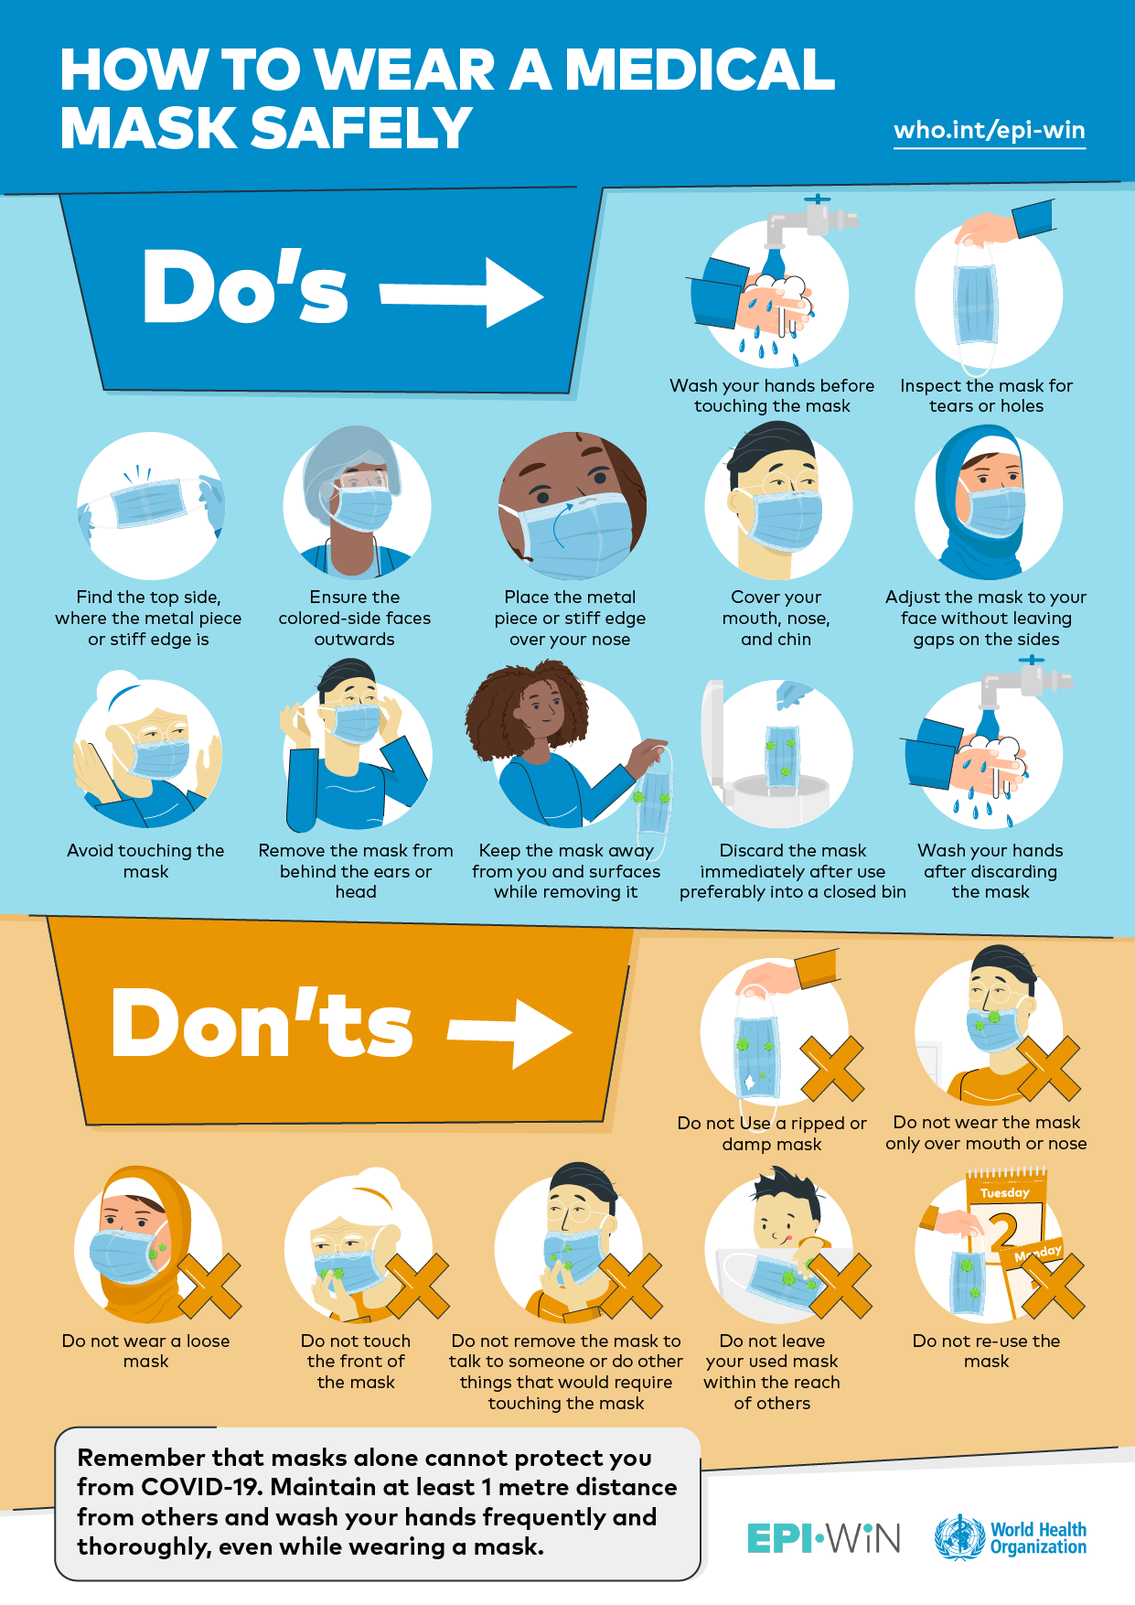
How to Wash Cloth Masks
Masks are an additional step to help slow the spread of COVID-19 when combined with every day preventive actions and social distancing in public settings.
Masks should be washed after each use. It is important to always remove masks correctly and wash your hands after handling or touching a used mask.
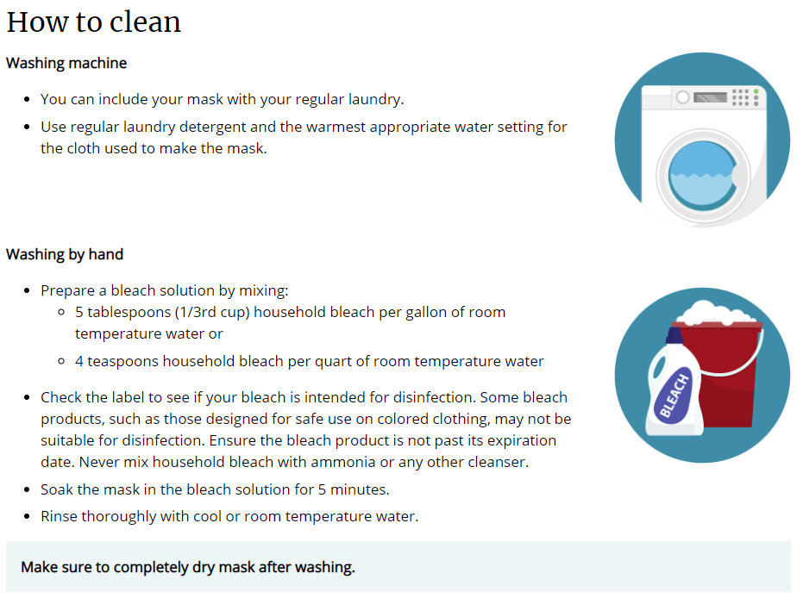
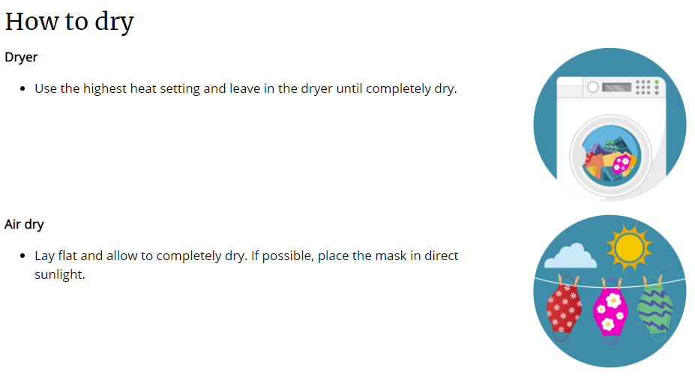

Career Opportunity Development, Inc.

Vocational Consumer Handbook Review Sheet

I, __________________________________________________,
(Have consumer write (print) name or request staff assistance)

Hereby acknowledge that I have reviewed Career Opportunity Development, Inc.’s “Vocational Consumer Handbook,” and understand the information that the handbook includes. This includes review of “Notices of Privacy Practices,” “Rights of Individuals Served,” and “Grievance Policy and Procedure.” All of my questions regarding the handbook have been answered to my satisfaction.

_______________________________ ______________________
Consumer’s signature Date

________________________________ ______________________
Facilitator’s signature Date

