**Career Opportunity Development, Inc.**

**SUPPORTED EMPLOYMENT SERVICES**

**CONSUMER HANDBOOK**

Developed November, 2004

Reviewed and revised September, 2011 Reviewed and revised August 2017 Reviewed and revised August 2020 Updated February 10, 2023

Table of Contents

FORWARD: 1

CRITERIA FOR ACCEPTANCE 2

PROGRAM LOCATION 3

INTRODUCTION TO SERVICES 3

Supported Employment Models 4

FOOD SERVICE POSITIONS 5

OVERVIEW OF SERVICES 5

GENERAL GUIDELINES 6

Work Schedules 6

Transportation 6

Employer Policies 7

Safety/ Consumer Injury 7

SERVICE DESCRIPTION 8

Pre-placement Activities 8

Job Development Activities 8

Job Matching 9

Interviewing Assistance 9

PAID SITUATIONAL ASSISTANCE 9

Job Coaching 9

Follow Along Services 10

Job Accommodations and Assistive Technology 10

SUPPORT SERVICES 10

Identification (ID) Card: 10

Reduced fare card 11

OTHER IMPORTANT INFORMATION 11

Input 11

Benefits 11

Wages 11

KNOW YOUR RIGHTS 12

Grievance and Appeal Procedure 14

HARASSMENT 18

ACCESS TO CONSUMER FILE 18

POLICY REGARDING INPUT FROM INDIVIDUALS SERVED 19

YOUR RESPONSIBILITIES 19

Keeping a Safe Workplace 21

General Hygiene Rules 21

Routine environmental cleaning and disinfection procedures 23

Entering the Building 23

How to Wash Cloth Masks 26

**FORWARD:**

On behalf of Career Opportunity Development, Inc. CODI would like to welcome you as a new consumer to Supported Employment Services. This manual will help

you learn about the services, activities, and opportunities we have to offer you.

Our goal is to help you find a job in your local community, to assist you in maintaining that work position, and help you advance in your career choices. We will assist you in achieving the specific goals that you and your support team have decided are best for you. After you read this manual, please feel free to ask any questions that you might

have of your Career Opportunity Development, Inc. Employment Specialist.

CODI does not discriminate against a person who applies for employment services based on race, color, creed, religion, sex, ancestry, age, national origin, marital status, sexual orientation, veteran status, political belief, physical or mental disability, including HIV or AIDS or other status protected by federal or state

statutes.

1

**CRITERIA FOR ACCEPTANCE**

1.

You have been referred for services by the New Jersey Division of Vocational Rehabilitation Services or N.J. Division of Developmental Disabilities.

2.

You have expressed an interest in a job that you believe that you would like or you could be trained to perform. The job that you want is available in your community.

3.

The important people in your life (your parents, siblings, and friends) are supportive of your desire to work competitively.

4.

You are able to get to a job using Access Link, public buses, taxi cabs, your own car, or help from your family or friends. If needed, you are willing to travel.

5.

You are willing to work the required hours and schedule of the job you are interested in.

6.

You know that getting a job may change your Social Security benefits, health care benefits, and other program benefits or income you are receiving.

2

**PROGRAM LOCATION**

Career Opportunity Development, Inc. provides services to you from the following location:

**Career Opportunity Development, Inc. Supported Employment Services**

**901 Atlantic Avenue**

**Egg Harbor City, N.J., 08215 609-965-6871**

**609-965-3099 (fax)**

**INTRODUCTION TO SERVICES**

How can someone receive services?

CODI Supported Employment Services are designed to assist individuals with disabilities acquire and maintain community based competitive employment. We

can accomplish this in a number of ways:

1.

2.

You are referred by NJ Division of Vocational Rehabilitation services.

You are referred by your Division of Developmental Disabilities (DDD) Case Manager, Support Coordinator or other interested advocates or organizations.

3

**Supported Employment Models**

***Individual Placement:***

This is the model most favored by New Jersey Division Vocational Rehabilitation Services, although they will fund mobile crews. In the individual placement model the service recipient, after assessment by the job coach or employment specialist and careful job matching, based on the individual’s desires and the skills which the individual possesses is placed in a community job in an integrated setting. All work conditions including dress code, call-out procedures, and how the individual is paid

are determined by the employer.

***MOBILE CREWS:***

Some DDD and DVRS funded individuals work on mobile crews performing janitorial work in various local offices and contracted sites. These individuals’ wages are paid by CODI. Paychecks are issued every other Friday and are either mailed to your residence or direct deposited into a bank account (see supervisor for direct

deposit information). Timesheets will be filled out by the Maintenance Supervisor.

Crew members must call their supervisor at least two hours before work if they are unable to work on a given work day during the week. The phone number is 609 965-

6871.

CODI provides Janitorial Crew members with uniforms. Crew members are expected to be in appropriate uniform when reporting to work and should dress in accordance to the weather forecast. Janitorial work can be hot and dirty and crew members should dress accordingly. It is important that those who work out in the heat dress for the weather and use sun screen.

Supervisors will be responsible for seeing that heat precautions are followed by crew members. This would include frequent water breaks, use of sun screen and monitoring

of clothing appropriate for hot weather.

4

***FOOD SERVICE POSITIONS:***

If you have an interest in food service, you may get an opportunity to work in the CODI Kitchen or our coffee shop outlets in the county courthouses. Individuals who work in the kitchen or coffee shops are paid every other Friday like crew members

and all other CODI employees.

As a CODI food service employee, you are required to call out to your supervisor at least two hours before you are due to report to work, when you are unable to work. Kitchen workers should call 609 965-5422 and coffee shop workers should call the appropriate outlet. Your job coach or employment specialist will provide you with

these numbers.

If you work in food service, you will be expected to follow the dress code for food service employees. The shoe requirement is a tennis shoe or leather type closed toe and rubber sole shoe. All jewelry must be worn in moderation and should not pose a safety risk. All clothing must conform to standards of modesty and cover body parts

from the neck to mid-thigh.

**OVERVIEW OF SERVICES**

In Supported Employment Services, a CODI staff person called an Employment Specialist will help you determine what type of job you want to look for and the type of assistance you will need to get and keep a job. The Employment Specialist will help you find a job and even go with you on the job interview(s), if you want

him/her to. He/she may also help you plan for your transportation to and from work.

Once you have found a job, the Employment Specialist will go with you at the beginning of your employment to help you learn your new surroundings and job duties. He/she will assist you in completing orientation and new hire training. The Employment Specialist may help teach you the job, or help your new employer teach you. He/ she will also help you meet your coworkers, learn the general rules of the

workplace, and discuss your employee benefits with you.

5

As you get better and better at doing your job duties, your Employment Specialist will spend less and less time with you at your place of employment. Eventually, usually within a few weeks, you will be able to work without the assistance of your Employment Specialist most of the time. You will continue to be supervised by your employer or immediate supervisor, who will give you support on a daily

basis.

After you have shown the ability to work independently of your CODI Employment Specialist, he/she will continue to visit you at the job every 2- 3 weeks. During these visits, you should tell your Employment Specialist how things are going on the job. If you feel you need more help of any kind, please tell your Employment Specialist right away. If you decide to quit your work position, please tell your Employment Specialist before you do anything. If you would like to apply for a promotion, please let your Employment Specialist know so he/she can assist you with this. If you decide to look for a new job in a new company, please let your Employment Specialist know of your intentions. You can talk to your Employment Specialist about any of these issues whenever he/she visits you, or call him/her at the CODI office 609 965-6871. You should feel free to contact your Employment Specialist at any time of the day or

evening that he/she is working.

**GENERAL GUIDELINES**

***Work Schedules***

Participants who work in community jobs will follow the work schedule set by their employers. Participants who work on enclaves will be given weekly schedules. Those

working in CODI food service outlets will be given a schedule by their supervisor.

***Transportation***

It is expected that you will be able to get to and from work using Access Link, public transportation, your own car, taxi cabs, or a ride you’re your residential staff or family

6

members. Your Employment Specialist will assist you in learning to travel to and from work if needed and will accompany you on public transportation vehicles as part of

your travel training needs.

***Employer Policies***

Your employer will have rules and guidelines for attendance, sick time, vacation, holiday time, dress code, benefits, and lunch breaks. The Employment Specialist will help you learn these rules so that you can follow them without their

assistance.

***Safety/ Consumer Injury***

Your employer will have specific rules regarding safety at the work place. The employer will review these with you. The Employment Specialist will also help to explain the safety rules to you, to support you in learning safe work practices.

Anyone injured while working must notify their supervisor immediately. A supervisor must be notified regardless of the severity of the injury. First Aid kits are located at all

Enclave locations, CODI vehicles and main administrative offices.

If an injury occurs during work hours or while on CODI property or Enclave the

following information must be provided to the supervisor:

•

•

•

•

•

Who was injured and all parties involved Type of injury

Time and location of injury

Immediate action taken- i.e.: called 911, first aid treatment, etc.

Anyone refusing medical assistance must complete a “Refusal of Medical Care” form.

7

**SERVICE DESCRIPTION**

***Pre-placement Activities***

Pre-placement activities are activities aimed at helping you obtain competitive employment.

These activities may include, but are not limited to the following:

1. Resume Development: Helping you develop a resume to give to potential employers. This resume will list your job goals, educational training, previous work experiences and accomplishments.
2. Completion of employment applications: Helping you obtain,

complete, and return job applications to potential employers.

**Job Development Activities**

Job development is the process of locating a job opportunity in the community that

matches your job goal. Some of the ways that you might learn of job openings include:

1.

2.

3.

4.

Classified ads in local newspapers Internet postings

Personal visits to local employers

Information about job openings from friends, relatives, or other persons that you talk with on a regular basis.

Career Opportunity Development, Inc. staff contacts with local

businessmen and industry and leads the way by hiring people with disabilities within their own organization.

5.

8

***Job Matching***

Job matching is the process in which your CODI Employment Specialist helps you look at your skills, abilities, interests, and needs and matches them to an available job opportunity in your local community. The Employment Specialist may ask you

many questions about your likes and dislikes to gather this information.

**Interviewing Assistance**

The CODI Employment Specialist will help you practice answering questions that many employers may ask when you interview for a job. He/she will help you prepare for these questions, as well as how to act and dress. If you would like, the

Employment Specialist will also go with you on the interview.

**PAID SITUATIONAL ASSISTANCE**

Situational assessment involves “trying out” a job to see if the job fits your interests, abilities, and needs, as well as those of the potential

employer. This gives you and the Employment Specialist the chance to see if the job

would be a good match for you and for you to receive paid training.

**Job Coaching**

Job coaching is the term used to describe the services that you will receive from your CODI Employment Specialist while you learn and remain on

your job. The type of job coaching support that you will receive is reviewed with you

and your employer at the time that you accept your position.

Job Coaching may include:

1.

2.

Training at the employer’s workplace to help you learn the job Linking you with community resources such as a social club or transportation.

Suggestions of ways to make your job easier for you to complete your assigned

9

3.

duties

Assisting you to learn the rules and regulations of your new job Assisting you to get to know your coworkers and supervisors

Meeting with you off the job to discuss problems or issues that are related

to your work performance

4.

5.

6.

***Follow Along Services***

As you become more comfortable in your job, your Employment Specialist, will step back or “fade” from your job site, but will continue to visit you after you have settled into your job. About twice a month your Employment Specialist may contact you to be sure you are continuing to do well on your job as long as you feel that you need this type of support. The Employment Specialist can spend more time with you if you need it to learn new tasks on the job, or you just want to see him/her more often for moral support. You may also receive additional job coaching if you get a promotion or change to a new job.

***Job Accommodations and Assistive Technology***

If your job requires work site modifications or you need any assistive devices to perform your job, your Employment Specialist will work with you and your employer to obtain any necessary changes. If you need help with assistive devices that Career Opportunity Development, Inc. cannot provide, we will contact an outside agency that

can provide the services that you need.

**SUPPORT SERVICES**

Your CODI Employment Specialist can help you find other services in the community that you might need that we cannot directly provide. Some examples of

these services are listed below:

***Identification (ID) Card:***

A non-driver identification card is available from the New Jersey Division of Motor

10

Vehicles (DMV). You can get an application form from any local DMV office to

obtain the ID card. You will need proof of identity before you can begin a job.

***Reduced fare card:***

A reduced fare card can be obtained from NJ Transit at no cost to you. The card will entitle you to half fare on public transportation (buses and trains) during non rush hours. To get an application call NJ Transit or your CODI Employment Specialist at

(609)-965-6871.

**OTHER IMPORTANT INFORMATION**

***Input***

Career Opportunity Development, Inc. Supported Employment Services is designed to meet your needs. We want and need your involvement in all aspects of service. Your input is important to our success in helping you reach your personal goals. If you have questions or concerns, at any time, feel free to contact your Employment Specialist or the Employment Specialist Supervisor. Employment Specialist and their supervisor are usually available between the hours of 8:30am and 4:30 pm. At all other times call 609 965-6871 and leave a message. We welcome any suggestions that will help us improve

our services.

***Benefits***

Your employer may provide benefits that could include medical insurance, sick time, vacation time, and other personal benefits. These benefits will vary depending

whether you work full time or part time.

***Wages***

Your employer will pay you an hourly rate that has been established for the position

that you have been hired to perform. Your salary cannot be lower than the current guidelines for the State of New Jersey minimum wage, unless they meet the standards

11

set by the Department of Labor for sub- standard wages, like tipped positions in the

food service industry.

**KNOW YOUR RIGHTS**

You should be aware of your rights as a worker and as a person. Here are some of

the rights that apply to individuals in CODI Supported.

All individuals receiving services from Career Opportunity Development, Inc. have rights that shall not be violated by CODI staff, board of directors, or volunteers.

Rights shall be received within five (5) days of admission.

It shall be the responsibility of staff, board of directors, and volunteers to ensure

the following consumer rights are maintained. The right to:

1.

Receive services without bias, discrimination, or harassment due to race, color, culture, creed, religion, sex (including pregnancy), family structure, gender non- conformance, actual or perceived sexual orientation or gender identity and expression, age, ancestry, national origin, nationality, ethnicity, language, socioeconomic status, marital status, domestic partner or civil union status, military status, political belief, atypical hereditary cellular blood trait, genetic information, mental or physical disability (including perceived disability, obesity, HIV or AIDS, alcoholism or substance use disorder who may or may not be in treatment or recovery from substance use disorder with legitimately prescribed medication[s]) or other status protected by applicable federal or state statutes, or

the ability to pay the Residential Service Fee;

2.

Receive services free of humiliation and neglect;

3.

Are protected from financial exploitation;

4.

Are treated professionally. Receive services provided honestly and ethically

reflecting values such as fairness, respect, courtesy, dignity, and good faith;

12

5.

Are free to express individual opinions and feelings without retaliation;

6.

Are free from corporal punishment;

7.

Are free from involuntary labor;

8.

Receive treatment in the least restrictive setting, free from physical restraints and

isolation;

9.

Not be presumed incompetent;

10. Receive reasonable accommodations for practice of the religion of their choice or

the right to abstain from religious practices;

11. Have access to adequate emergency medical treatment;

12. Actively participate in development of individual service plan;

13. Have access to review EPHI/PHI/PII and request revision of information;

14. Have the right to present a grievance and receive a response without retaliation as

outlined in the Grievance Procedure;

15. Have the right to speak for themselves, make decisions, contribute to society, and

when needed, request staff to advocate on their behalf;

16. Have access to interpreter services;

17. Not to be included in research project or studies unless notified in writing before admission or enrollment of inclusion in research project and the extent to which they will be included. In addition, it is understood that participation in research project is strictly voluntary, and CODI shall endeavor to ensure project is conducted ethically. CODI shall also require researchers to sign a statement

indicating research will be conducted ethically;

18. Have all information obtained through EPHI/PHI/PII or daily interaction

maintained in confidence.

If you think your employee rights are being violated at your workplace, your CODI

13

Employment Specialist can help you to report your concerns to your employer. Career Opportunity Development, Inc cannot provide you with direct legal

assistance.

**Grievance and Appeal Procedure**

A grievance is an official statement of complaint over something believed to be wrong or unfair. Consumers have 30 calendar days after an incident to file a grievance.

Consumers may file a grievance if they believe they witnessed or experienced CODI staff:

1.

2.

3.

4.

5.

6.

Disregarding consumer rights Treating consumer unfairly

Not providing services offered by the program Intimidating or bullying consumer

Treating consumer inhumanely or without dignity Allowing consumer to be put at risk by another consumer

Grievances do not include consumer to consumer complaints. No one will be punished for filing a grievance. CODI will continue to provide services while trying to resolve the grievance.

CODI encourages consumers to talk to staff about their concerns before filing a grievance. If the grievance is not resolved, CODI encourages consumers to talk with a supervisor where they work, live, or receive services.

If the concern is not resolved, please obtain a grievance form online at [www.njcodi.org](http://www.njcodi.org/) or request a grievance form from any CODI staff member. Forward completed grievance form electronically to [TWinchester@njcodi.org](mailto:TWinchester@njcodi.org) or mail completed form to:

CODI

Attention: Taran Winchester (Director of Quality Improvement) 901 Atlantic Avenue

Egg Harbor City, NJ 08215

Taran Winchester, the Director of Quality Improvement will:

1. Confirm grievance was received.
2. Begin investigation of grievance within three days of receipt.

14

1. Complete an investigation within ten days of receipt.
2. Notify all parties of the outcome within five days of completing the investigation.

If not satisfied with the decision, the consumer may appeal the decision to the President/CEO. The appeal must be in writing and received by President/CEO within five business days of receipt of grievance outcome report. President/CEO will respond within five business days.

15

**Grievance Form**

Name(s) of individual(s) submitting grievance:

Summary of grievance:

Requested actions to resolve grievance:

Signature of Program Participant or staff submitting grievance on behalf of a consumer:

Date:

Please email this form to [twinchester@njcodi.org](mailto:twinchester@njcodi.org) or have staff scan for you, or mail completed form to:

Career Opportunity Development, Inc. Attention: Taran Winchester (DQI) 901 Atlantic Avenue

Egg Harbor City, NJ 08215

□ To Quality Improvement Date:

□ To Human Resources

Date:

□ To Risk Management Committee

Date:

CIR □ Yes □ No ; If Yes, # DAF □ Yes □ No

□ Other:

16

CODI encourages consumers to use our grievance procedure. If you are not satisfied you may contact the external resources listed below:

**In New Jersey, Call 2-1-1 for Help and Hot Lines** <http://www.nj211.org/>

Community Health Law Project (856) 858-9500

4 East Jimmie Leeds Road, Suite 8, Galloway, NJ 08205

<http://www.chlp.org/>

Adult Protective Services (609) 645-5965 or (888) 426-9243

101 Shore Rd, Room 210, Northfield, NJ 08225 ...........................................................

<http://www.atlantic-county.org/intergenerational-services/adult-protective-services.asp>

Disability Rights NJ ..............................................(609) 292-9742 or (800) 922-7233

210 S Broad St, 3rd Floor, Trenton, NJ 08608 <http://www.drnj.org/>

Atlantic County Mental Health Administrator.................... (609) 645-7700 ext. 4519 Attn: Kathy Quish email: [Quish_Kathleen@aclink.org](mailto:Quish_Kathleen@aclink.org)

101 S Shore Rd, Northfield, NJ 08225

NJ Division of Mental Health & Addiction Services (877)285-2844

Mental Health Advocacy, Hughes Justice Complex, 25 Market St, Trenton, NJ 08625 <http://www.nj.gov/defender/structure/mha/> email: [njmentalhealthcares@mhanj.org](mailto:njmentalhealthcares@mhanj.org)

NJ Division of Mental Health & Addiction Services (DMHAS)

Recovery Advocate (609) 438-4351

Ombudsperson/Susanne Mills (609) 438-4321

5 Commerce Way, Suite 100, P.O. Box 362, Hamilton, NJ 08625 <http://www.state.nj.us/humanservices/dmhas/resources/services/recovery/advocate.html>

NJ Division of Youth and Family Services (DYFS).. 877-NJ-ABUSE (877) 652-2873 Child Protection Services DYFS Action Line (800) 331-3937

<http://www.state.nj.us/nj/community/family/>

NJ Division of Developmental Disabilities (DDD) (609) 476-5200

5218 Atlantic Ave, Suite 205, Mays Landing, NJ 08330 <http://www.state.nj.us/humanservices/ddd/home/>

NJ Division of Vocational Rehabilitation (609) 813-3993 or (609) 292-5987

2 S. Main St, 1st Floor, Suite 2, Pleasantville, NJ 08232 or, PO Box 398, Trenton, NJ 08625<http://www.state.nj.us/humanservices/cbvi/services/vocation/>

Atlantic County Government/Fran Kuhn ............................. (609) 485-0153 ext 4809 2 S. Main St, Pleasantville, NJ 08232

17

**HARASSMENT**

Harassment of any kind due to age, ancestry, color creed, marital status, national origin, physical or mental handicap, race, religion, or sex is demeaning to both the victim and the agency. Furthermore, such conduct is against the law. CODI will not tolerate any harassment directed towards staff or co-workers and will take affirmative steps to discourage and eliminate any form of harassment. Harassment can include jokes, comments, or other personally offensive and unwelcome behavior based on the characteristics noted above that create a hostile, offensive, or intimidating work atmosphere. If you believe that you are being harassed based on the above, immediately inform the harasser that you find the behavior offensive, and that such language or behavior is against CODI policy, and ask them to discontinue such actions. If the harassment continues, immediately report the incident to your supervisor or your counselor. Consumers found to be harassing others will be subject to disciplinary action up to and including interruption of services. If the harassment occurs on your new job, you may ask your job coach or employment specialist to

advocate for you with your employer.

**ACCESS TO CONSUMER FILE**

All file information is confidential. It is your right to view your file, but the following procedure must be followed.

Consumer Request for File Information Form must be filled out in its entirety and

signed by the consumer. (By your guardian, if you have one.)

Upon completion of this form, it is to be submitted to the VP of Organizational

Employment Services, who will review the request and respond within ten working days.

Note: Only CODI generated reports and documentation will be released.

18

**POLICY REGARDING INPUT FROM INDIVIDUALS SERVED**

CODI Board of Directors, president, management, and staff are committed to providing quality services that meet consumer needs within the scope of the organization’s mission/vision. Vocational program development takes into consideration the needs, expectations, and input of individuals served as expressed in

satisfaction surveys and in individual and group communication.

In addition, input from persons served is gathered on a regular basis from Consumer Opinion Surveys, obtained upon transitioning from one program to another and from follow-up information collected at case closure.

Consumer input and participation is also obtained through a Consumer

Advocacy Committee.

You can be your own best advocate. Ask your Employment Specialist about joining a

self-advocacy group.

**YOUR RESPONSIBILITIES**

1.

Job Seeking: It is important that you are actively involved in all aspects of your job search. It is expected that you will consider realistic job offers that match your employment goal(s).

Employment: Your employer will have policies and procedures that you will need to follow in order to stay employed. It is expected that you will try your best to follow the work rules for attendance, punctuality, safety, lunch and break times, and all of the other policies that your employer may have in place. Respect: You should always try to show respect for CODI staff,

employers, and your coworkers.

Transportation: You must be able to use any means of accessible transportation that is available to you. You must be willing to be travel trained, if necessary.

2.

3.

4.

19

Transportation fees are your responsibility.

Cooperation: You will need to cooperate and get along with staff, supervisors, and coworkers to the best of your ability.

5.

20

**ADDENDUM FOR COVID-19**

The following requirements must be taken to protect self, other consumers, and staff from coronavirus or other infectious diseases. **These requirements override any conflicting procedures written above and will be followed until further notice.**

•

Do not report to work with COVID-19 symptoms including coughing, shortness of breath or difficulty breathing, fever or chills, muscle or body aches, fatigue, vomiting or diarrhea, or new loss of taste or smell and notify a supervisor if illness occurs throughout the day.

Notify CODI of positive COVID-19 test results for self or anyone residing in the household. Note from doctor or Department of Health confirming recovery, and a negative test for the virus is needed for return.

If in close contact with someone infected by COVID-19, consumer may not return to program for 14 calendar days after the last contact with infected person provided. Also, consumer must not have any symptoms and must test ~~s~~ negative for the virus. Consumer should not come into physical contact with any other CODI consumer or staff during this time.

Provide CODI with a copy of all test results.

•

•

•

**Keeping a Safe Workplace**

The protocol for protecting self and others in the workplace against COVID-19 is outlined by the Center for Disease Control (CDC) guidelines. These are simple everyday practices that can be used both at home and in the workplace to protect against bacteria and viruses and are included in the general hygiene rules below.

**General Hygiene Rules**

•

•

Practice social distancing.

Wash hands with warm water and soap for at least 20 seconds after using the restroom, coughing into hand, blowing nose, eating, and throughout the workday.

Cough/sneeze into elbow. If tissue is used, place tissue in trashcan and wash hands immediately.

Avoid touching face, nose, mouth, and eyes.

•

•

21

* Avoid handshaking, high fives, and fist bumps.
* Put distance between self and others – preferably 6 feet when available.

**Facemasks**

•

Until wearing facemasks indoors is no longer required by the State of NJ consumers and staff must wear a facemask covering nose and mouth when entering CODI and while in the building.

Facemask may only be removed when eating lunch.

Consumers are strongly encouraged to wear a facemask brought from home; however, if mask breaks, becomes soiled, or is forgotten, a mask will be provided by CODI.

•

•

**Lunch**

•

•

•

•

•

Consumers must remain on-site for lunch.

Lunch must be provided from home or purchased from CODI’s kitchen. Food take out/deliveries are not permitted.

Consumers are not permitted to share lunches, snacks, or beverages with others.

Microwaves, refrigerators, and water fountains are not available to reduce frequently touched items.

Lunch will be eaten at workstations.

•

**Restrooms**

•

•

Only one person at a time is permitted in the restroom.

Touch-sensitive lights by restrooms must be used, which indicate when restroom is in use. Turn light on and off with elbow, instead of hand.

Restrooms must stay clean. Dispose of paper products properly and completely flush toilets.

•

22

* Consumers must wash hands for 20 seconds using soap and water after using restroom. As a reminder, signs are posted in restrooms with CDC instructions for proper hand washing.

**Routine environmental cleaning and disinfection procedures**

* All high touch areas will be sanitized four times daily.
* Consumers are required to disinfect work area before work begins, before and after lunch, and end of shift.

**Social distancing requirements**

•

Until social distancing is no longer required by the State of NJ everyone at CODI must practice social distancing.

Chairs and tables are spaced to follow social distancing guidelines. Consumers may not move chairs to sit closer to other consumers or for any other reason. Chairs are to stay at opposite ends of each table.

Seats are assigned, and consumers will return to assigned seats daily to minimize contact with other consumers.

Consumers must follow one-way walking paths in Outsource Center.

Lockers are off-limits until social distancing measures are loosened. Personal belongings can be stored under workstations. CODI will provide storage containers at consumer's request.

Consumers are not permitted to assist staff or customers with deliveries or drop-offs.

•

•

•

•

•

**Hand Sanitizing Stations**

Hand sanitizer dispensers are placed throughout the building in workstations, common areas, offices, and meeting rooms. Consumers are encouraged to use hand sanitizer throughout the day as needed.

**Entering the Building**

Consumers must adhere to the following guidelines when entering the building:

23

•

Consumers and staff are required to complete a temperature check using the non-contact body temperature scanner upon entering the facility.

Consumers or staff appearing to have acute respiratory illness symptoms (i.e., cough, shortness of breath) or exhibit a fever upon entrance will immediately exit the building and return home. If this is not possible, consumer will be required to remain in the isolation room until arrangements to return home are completed.

At the end of each day, consumers must remain at assigned table until transportation arrives to avoid overcrowding exit.

~~•~~

•

**Transportation**

CODI will not be providing transportation services upon reopening.

24





**HOW TO WEAR A MEDICAL MASK SAFELY**

who.int/epi-win

'..\

Wash your hands before Inspect the mask for

touching the mask

tears or holes

Find the top side, where the metal piece or stiff edge is

Ensure the colored-side faces

outwards

Place the metal piece or stiff edge over your nose

Cover your mouth, nose, and chin

Adjust the mask to your face without leaving gaps on the sides

-+-

'. \

Avoid touching the mask

Remove the mask from behind the ears or head

Keep the mask away fromyouandsurfaces while removing it

Discard the mask immediately after use preferably into a closed bin

Wash your hands after discarding the mask

Do not Use a ripped or damp mask

Do not wear the mask only over mouth or nose

Do not wear a loose mask

Do not touch the front of the mask

Do not remove the mask to talk to someone or do other things that would require touching the mask

Do not leave your used mask within the reach of others

Do not re-use the mask

**Remember that masks alone cannot protect you**

**from COVID-19.Maintain at least 1 metre distance from others and wash your hands frequently and**

**t horoughly, even while wearing a mask.**

**EP l•WiN** World Health Organization

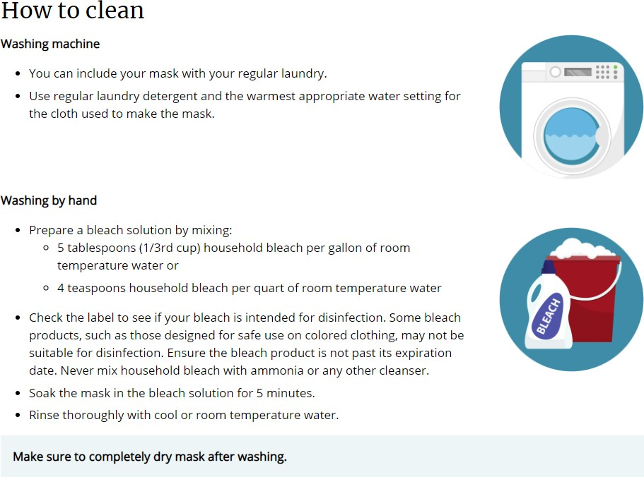

How to Wash Cloth Masks

Masks are an additional step to help slow the spread of COVID-19 when combined with [every](https://www.cdc.gov/coronavirus/2019-ncov/prevent-getting-sick/prevention.html) [day preventive actions](https://www.cdc.gov/coronavirus/2019-ncov/prevent-getting-sick/prevention.html) and [social distancing](https://www.cdc.gov/coronavirus/2019-ncov/prevent-getting-sick/social-distancing.html) in public settings.

Masks should be washed after each use. It is important to always [remove masks](https://www.cdc.gov/coronavirus/2019-ncov/prevent-getting-sick/how-to-wear-cloth-face-coverings.html) [correctly](https://www.cdc.gov/coronavirus/2019-ncov/prevent-getting-sick/how-to-wear-cloth-face-coverings.html) and [wash your hands](https://www.cdc.gov/handwashing/index.html) after handling or touching a used mask.

26

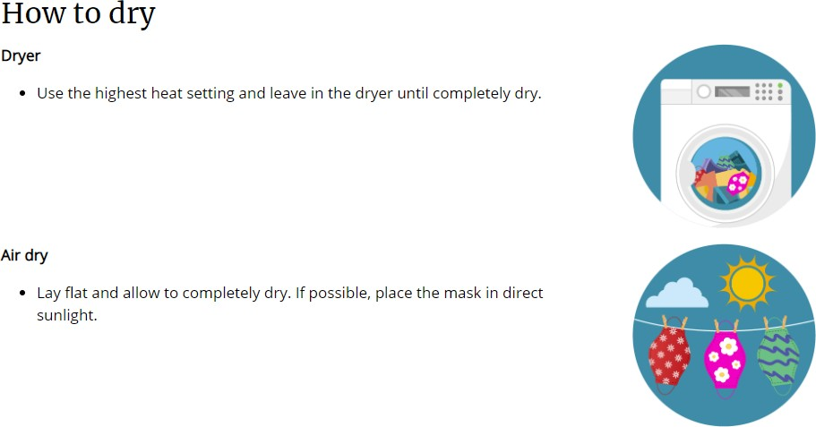

27

**CAREER OPPORTUNITY DEVELOPMENT, INC. SUPPORTED EMPLOYMENT SERVICES CONSUMER**

**ACKNOWLEDGEMENT FORM**

I, , hereby acknowledge the recipient of a copy of the CODI Supported Employment Services Consumer Handbook. This manual provides the necessary information on policies, assistance techniques, guidelines, and various

options available to me through this service area.

Signed:

Date:

Job coach or employment specialist Signature

Supported Employment Consumer Handbook